Discovering interpretable features

unsupervized learning -4

discovering interpretable features

Non-negative matrix factorization (NMF)
● NMF = "non-negative matrix factorization"
● Dimension reduction technique
● NMF models are interpretable (unlike PCA)
● Easy to interpret means easy to explain!
● However, all sample features must be non-negative (>= 0)

compare with LDA, SVD
- https://www.quora.com/Whats-the-difference-between-SVD-NMF-and-LDA-as-topic-model-algorithms-essentially
- https://www.quora.com/What-are-the-pros-and-cons-of-LDA-and-NMF-in-topic-modeling

Interpretable parts
● NMF expresses documents as combinations of topics (or "themes")
● NMF expresses images as combinations of patterns
import pandas as pd

import matplotlib.pyplot as plt
%matplotlib inline
plt.imshow(plt.imread('img.jpg'))
plt.axis('off')
(-0.5, 740.5, 246.5, -0.5)
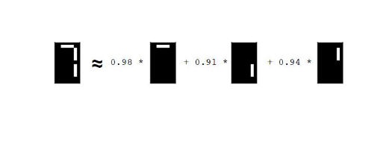

Example word-frequency array
● Word frequency array, 4 words, many documents
● Measure presence of words in each document using "tf-idf"
● "tf" = frequency of word in document
● "idf" reduces influence of frequent words

http://www.tfidf.com/

Term Frequency
TF: Term Frequency, which measures how frequently a term occurs in a document. Since every document is different in length, it is possible that a term would appear much more times in long documents than shorter ones. Thus, the term frequency is often divided by the document length (aka. the total number of terms in the document) as a way of normalization:
TF(t) = (Number of times term t appears in a document) / (Total number of terms in the document).

Inverse Document Frequency
IDF: Inverse Document Frequency, which measures how important a term is. While computing TF, all terms are considered equally important. However it is known that certain terms, such as "is", "of", and "that", may appear a lot of times but have little importance. Thus we need to weigh down the frequent terms while scale up the rare ones, by computing the following:
IDF(t) = log_e(Total number of documents / Number of documents with term t in it).

Example:
Consider a document containing 100 words wherein the word cat appears 3 times. The term frequency (i.e., tf) for cat is then (3 / 100) = 0.03. Now, assume we have 10 million documents and the word cat appears in one thousand of these. Then, the inverse document frequency (i.e., idf) is calculated as log(10,000,000 / 1,000) = 4. Thus, the Tf-idf weight is the product of these quantities: 0.03 * 4 = 0.12.
from sklearn.decomposition import PCA
print str(PCA).split('.')[-1].replace("'>",'')
PCA

Curious

apply dimensional reduction techniques on image
- PCA
- NMF
- SVD
cat = plt.imread('cat.jpg')
print cat.shape
plt.imshow(cat)
(194L, 259L, 3L)
<matplotlib.image.AxesImage at 0xc951e80>
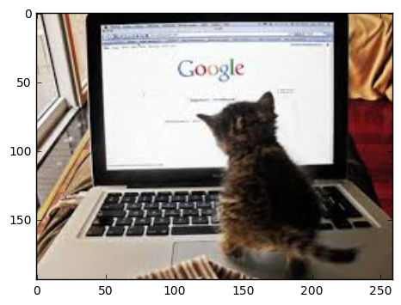

write functions for comparison
- read image matrix
def curiosity(image, n):
from sklearn.decomposition import PCA, NMF, TruncatedSVD
import numpy as np

## turn color image to black and white
try:
image = image.mean(axis=2)
except:
pass

models = [PCA, NMF, TruncatedSVD]
results = []

c = 0

plt.figure(figsize= (12,12))

for i in models:
c+=1

m = i(n)
d = m.fit_transform(image)
a = m.inverse_transform(d)
results.append(a)

plt.subplot(1,3,c)
plt.imshow(a, cmap='gray')
plt.axis( 'off')

title = str(i).split('.')[-1].replace("'>",'')
plt.title(title, size=15)

print '3 dementional reduction algorithms with compressing of '
print 'Number of components: '+ str(n)

return results

test10 = curiosity(cat,10)
3 dementional reduction algorithms with compressing of
Number of components: 10
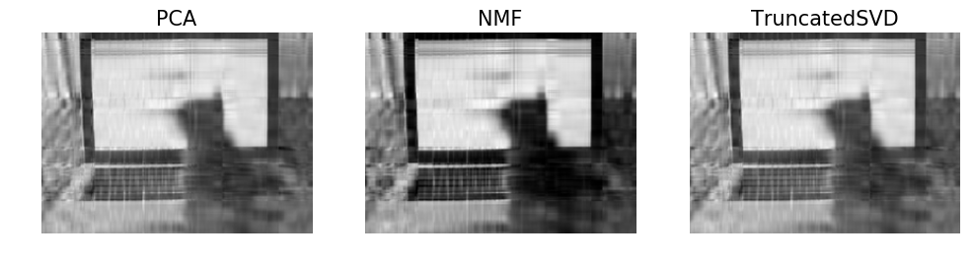
test20 = curiosity(cat,30)
3 dementional reduction algorithms with compressing of
Number of components: 30
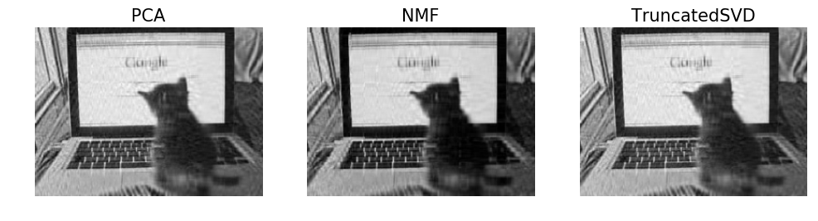
test20 = curiosity(cat,50)
3 dementional reduction algorithms with compressing of
Number of components: 50
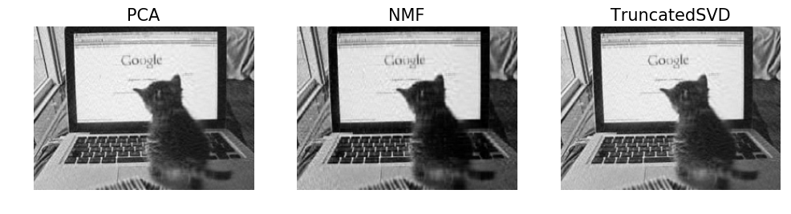
test20 = curiosity(cat,5)
3 dementional reduction algorithms with compressing of
Number of components: 5
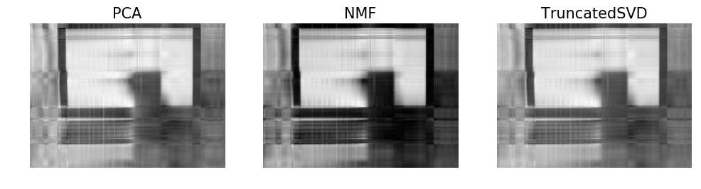

Using scikit-learn NMF
● Follows fit() / transform() pattern
● Must specify number of components e.g. NMF(n_components=2)
● Works with NumPy arrays and with csr_matrix

NMF components
● NMF has components
● ... just like PCA has principal components
● Dimension of components = dimension of samples
● Entries are non-negative
df = pd.read_csv('tweets.csv')
df = df['text']
df.shape
(615L,)
from sklearn.feature_extraction.text import TfidfVectorizer

tfidf = TfidfVectorizer()

sparse = tfidf.fit_transform(df)
print sparse.shape
sparse
(615, 1286)
<615x1286 sparse matrix of type '<type 'numpy.float64'>'
with 10947 stored elements in Compressed Sparse Row format>

apply NMF
- assume there are 4 categories on the documents
# Import NMF
from sklearn.decomposition import NMF
# Import pandas
import pandas as pd

# Create an NMF instance: model
model = NMF(n_components=4)

# Fit the model to articles
model.fit(sparse)

# Transform the articles: nmf_features
nmf_features = model.transform(sparse)

# Print the NMF features
print(nmf_features.shape)

# Create a pandas DataFrame: nmf
nmf = pd.DataFrame(nmf_features)
(615L, 4L)

each row(article) belongs to which column(group)
nmf.tail()
 | 0 | 1 | 2 | 3
610 | 0.009678 | 0.006492 | 0.021078 | 0.007579
611 | 0.011301 | 0.004056 | 0.019930 | 0.004390
612 | 0.280871 | 0.000000 | 0.000000 | 0.000000
613 | 0.280871 | 0.000000 | 0.000000 | 0.000000
614 | 0.280871 | 0.000000 | 0.000000 | 0.000000

NMF

Reconstruction of a sample
print nmf_features.shape
print model.components_.shape
print
print sparse.shape
(615L, 4L)
(4L, 1286L)

(615, 1286)

NMF fits to non-negative data, only
● Word frequencies in each document
● Images encoded as arrays
● Audio spectrograms
● Purchase histories on e-commerce sites
● … and many more!

Sample reconstruction
● Multiply components by feature values, and add up
● Can also be expressed as a product of matrices
● This is the "Matrix Factorization" in "NMF"

https://en.wikipedia.org/wiki/Non-negative_matrix_factorization

simulate
- the Multiple of two matrix
import numpy as np
ori = np.random.randint(1,100,30).reshape(5,6)
ori.shape
(5L, 6L)
from sklearn.decomposition import NMF

nmf = NMF(77)

after = nmf.fit_transform(ori)
after.shape
(5L, 77L)
nmf.components_.shape
(77L, 6L)
ori
array([[14, 64, 97, 64, 92, 95],
[42, 23, 94, 10, 26, 89],
[35, 98, 41, 13, 18, 82],
[42, 53, 38, 73, 10, 55],
[79, 9, 82, 16, 56, 32]])
np.dot(after, nmf.components_)
array([[ 14.00000006, 63.99994588, 97.00000111, 63.99999669,
92. , 94.99999999],
[ 41.99999999, 23.03224165, 93.99999996, 9.99996018,
26. , 88.99999991],
[ 35. , 98. , 41.00001475, 13. ,
18. , 82. ],
[ 42. , 53.00004969, 37.99999898, 73.00000304,
10. , 55. ],
[ 79.00000001, 9.00063528, 82.00000003, 16.00005237,
56. , 32.00000009]])

NMF components
● For documents:
● NMF components represent topics
● NMF features combine topics into documents
● For images, NMF components are parts of images
plt.imshow(plt.imread('digit.jpg'))
<matplotlib.image.AxesImage at 0x14406e80>
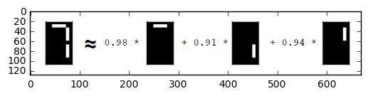

Grayscale images
● "Grayscale" image = no colors, only shades of gray
● Measure pixel brightness
● Represent with value between 0 and 1 (0 is black)
● Convert to 2D array
test = np.array([[ 0. ,1., 0.5], [ 1., 0., 1. ]])
test
array([[ 0. , 1. , 0.5],
[ 1. , 0. , 1. ]])
plt.figure(figsize=(3,2))
plt.imshow(test, cmap='gray', interpolation='nearest')
<matplotlib.image.AxesImage at 0xd910198>
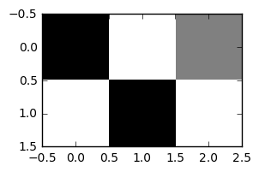

Grayscale image example
● An 8x8 grayscale image of the moon, written as an array
test2 = np.array([[ 0., 0., 0. ,0., 0. ,0. ,0., 0. ]
,[ 0. ,0. ,0. ,0.7, 0.8 ,0., 0., 0. ]
,[ 0. ,0. ,0.8 ,0.8, 0.9 ,1. ,0. ,0. ]
,[ 0. ,0.7, 0.9, 0.9, 1. ,1., 1., 0. ]
,[ 0. ,0.8, 0.9, 1. ,1. ,1. ,1. ,0. ]
,[ 0. ,0. ,0.9 ,1. ,1. ,1., 0., 0. ]
,[ 0. ,0. ,0. ,0.9, 1. ,0. ,0., 0. ]
,[ 0. ,0. ,0. ,0, 0., 0., 0., 0. ]])
test2
array([[ 0. , 0. , 0. , 0. , 0. , 0. , 0. , 0. ],
[ 0. , 0. , 0. , 0.7, 0.8, 0. , 0. , 0. ],
[ 0. , 0. , 0.8, 0.8, 0.9, 1. , 0. , 0. ],
[ 0. , 0.7, 0.9, 0.9, 1. , 1. , 1. , 0. ],
[ 0. , 0.8, 0.9, 1. , 1. , 1. , 1. , 0. ],
[ 0. , 0. , 0.9, 1. , 1. , 1. , 0. , 0. ],
[ 0. , 0. , 0. , 0.9, 1. , 0. , 0. , 0. ],
[ 0. , 0. , 0. , 0. , 0. , 0. , 0. , 0. ]])
plt.figure(figsize=(3,2))
plt.imshow(test2, cmap='gray', interpolation='nearest')
<matplotlib.image.AxesImage at 0xa21a588>
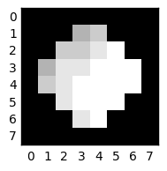

Grayscale images as flat arrays
● Enumerate the entries
● Row-by-row
● From le" to right
test
array([[ 0. , 1. , 0.5],
[ 1. , 0. , 1. ]])
test.flatten()
array([ 0. , 1. , 0.5, 1. , 0. , 1. ])

Encoding a collection of images
● Collection of images of the same size
● Encode as 2D array
● Each row corresponds to an image
● Each column corresponds to a pixel
● ... can apply NMF!
new = np.vstack([test.flatten(), test.flatten()+1, test.flatten()-1])
new
array([[ 0. , 1. , 0.5, 1. , 0. , 1. ],
[ 1. , 2. , 1.5, 2. , 1. , 2. ],
[-1. , 0. , -0.5, 0. , -1. , 0. ]])

NMF learns topics of documents
- when NMF is applied to documents, the components correspond to topics of documents, and the NMF features reconstruct the documents from the topics.

build a NMF on tweets
df = pd.read_csv('tweets.csv')
print df.shape
text = df['text']
print text.shape
(615, 33)
(615L,)
from sklearn.feature_extraction.text import TfidfVectorizer
tfidf = TfidfVectorizer()

matrix = tfidf.fit_transform(text)
matrix
<615x1286 sparse matrix of type '<type 'numpy.float64'>'
with 10947 stored elements in Compressed Sparse Row format>

NMF
- assume 6 topics
from sklearn.decomposition import NMF
nmf = NMF(6)
nmf
NMF(alpha=0.0, beta=1, eta=0.1, init=None, l1_ratio=0.0, max_iter=200,
n_components=6, nls_max_iter=2000, random_state=None, shuffle=False,
solver='cd', sparseness=None, tol=0.0001, verbose=0)
nmf_data = nmf.fit_transform(matrix)
print nmf_data.shape
print nmf.components_.shape
(615L, 6L)
(6L, 1286L)

nmf.components_
- stores information of each topic (6 topic)
  - the weights of words in each topic
# Create a DataFrame: components_df
components_df = pd.DataFrame(nmf.components_, columns=['words_'+str(i) for i in range(1,nmf.components_.shape[-1]+1)])

# Print the shape of the DataFrame
print(components_df.shape)
(6, 1286)
components_df.head(3)
 | words_1 | words_2 | words_3 | words_4 | words_5 | words_6 | words_7 | words_8 | words_9 | words_10 | ... | words_1277 | words_1278 | words_1279 | words_1280 | words_1281 | words_1282 | words_1283 | words_1284 | words_1285 | words_1286
0 | 0.000000 | 0.0 | 0.000053 | 0.000000 | 0.000000 | 0.0 | 0.0 | 0.0 | 0.000094 | 0.000000 | ... | 0.000000 | 0.000136 | 0.000644 | 0.000000 | 0.0 | 0.000000 | 0.0 | 0.0 | 0.000000 | 0.000000
1 | 0.000000 | 0.0 | 0.000271 | 0.000034 | 0.000103 | 0.0 | 0.0 | 0.0 | 0.000000 | 0.000105 | ... | 0.000000 | 0.001443 | 0.000851 | 0.000078 | 0.0 | 0.000020 | 0.0 | 0.0 | 0.000000 | 0.000000
2 | 0.000443 | 0.0 | 0.003419 | 0.000000 | 0.000641 | 0.0 | 0.0 | 0.0 | 0.002472 | 0.000000 | ... | 0.005707 | 0.009409 | 0.002365 | 0.000000 | 0.0 | 0.004375 | 0.0 | 0.0 | 0.000137 | 0.000326
3 rows × 1286 columns
# Select row 3: component
component = components_df.iloc[3]
# Print result of nlargest
print(component.nlargest(25))
words_154 0.753039
words_1275 0.499014
words_213 0.484263
words_523 0.484263
words_614 0.484263
words_721 0.484263
words_1047 0.484263
words_1089 0.484263
words_1136 0.484263
words_1115 0.482416
words_1005 0.481395
words_706 0.480707
words_1038 0.480517
words_146 0.480323
words_372 0.440320
words_913 0.166741
words_433 0.037140
words_1088 0.026446
words_478 0.025819
words_792 0.024422
words_85 0.019610
words_214 0.019610
words_264 0.019610
words_1011 0.019610
words_1163 0.019610
Name: 3, dtype: float64

Explore the image parts dataset, each is 2*3
image = np.array([0,1,0,1,0,1]).reshape(2,-1)
plt.imshow(image, cmap='gray', interpolation='nearest')
<matplotlib.image.AxesImage at 0x18557f98>
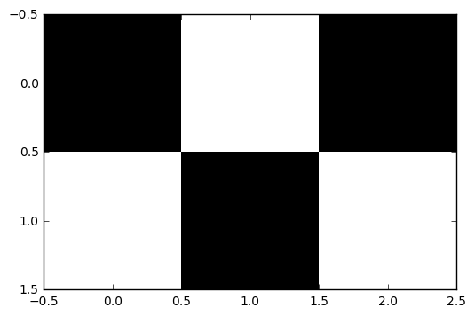

simulate 100 samples of constructing image of digits 2*3
sample = np.random.binomial(1,.5,6*100)
sample = sample.reshape(100,-1)
sample.shape
(100L, 6L)

write a function to print an image
def show(array):
plt.imshow(array.reshape(2,-1), cmap='gray', interpolation='nearest')
show(sample[3,:])
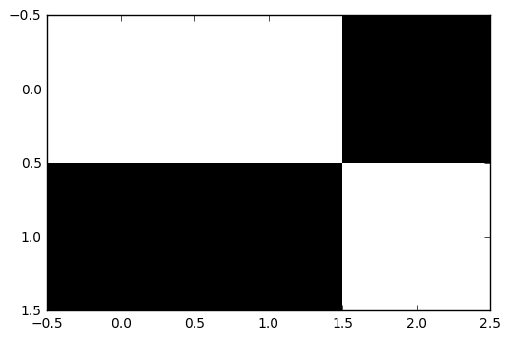

NMF learns the parts of images
- there are 6 features on each image
# Import NMF
from sklearn.decomposition import NMF

# Create an NMF model: model
model = NMF(n_components=6)

features = model.fit_transform(sample)
model.components_.shape
(6L, 6L)
# Call show_as_image on each component
plt.figure(figsize=(12,10))
c=0
n = len(model.components_)
for component in model.components_:
c+=1
plt.subplot(n, 1, c)
show(component)
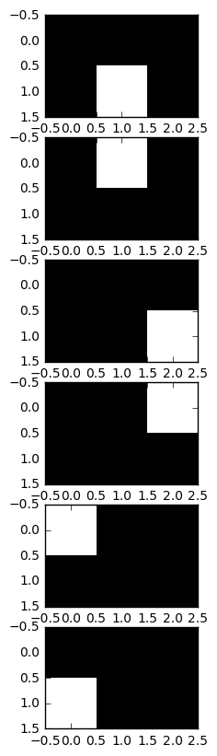

PCA doesn't learn parts
- Unlike NMF, PCA doesn't learn the parts of things. Its components do not correspond to topics (in the case of documents) or to parts of images, when trained on images. Verify this for yourself by inspecting the components of a PCA model fit to the dataset
- colors a pixel red if the value is negative.
# Import PCA
from sklearn.decomposition import PCA

# Create a PCA instance: model
model = PCA(n_components=6)

# Apply fit_transform to samples: features
features = model.fit_transform(sample)

# Call show_as_image on each component
plt.figure(figsize=(12,10))
c=0
n = len(model.components_)
for component in model.components_:
c+=1
plt.subplot(n, 1, c)
show(component)

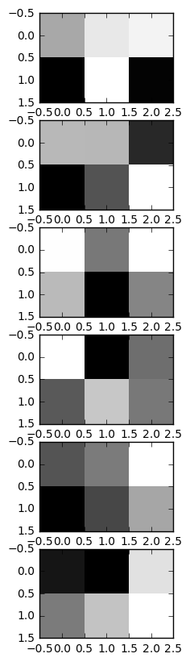

Building recommender systems using NMF

Finding similar articles
● Engineer at a large online newspaper
● Task: recommend articles similar to article being read by customer
● Similar articles should have similar topics

Strategy
● Apply NMF to the word-frequency array
● NMF feature values describe the topics
● ... so similar documents have similar NMF feature values
● Compare NMF feature values?

Apply NMF to the word-frequency array
● articles is a word frequency array
df = pd.read_csv('tweets.csv')
df = df['text']
df.shape

from sklearn.feature_extraction.text import TfidfVectorizer

tfidf = TfidfVectorizer()

sparse = tfidf.fit_transform(df)
print sparse.shape
sparse

from sklearn.decomposition import NMF
nmf = NMF(6)
nmf

nmf_data = nmf.fit_transform(matrix)
print nmf_data.shape
print nmf.components_.shape
(615, 1286)
(615L, 6L)
(6L, 1286L)

as you can see above, there are 615 posts, 1286 words, and 6 categories

Versions of articles
● Different versions of the same document have same topic proportions
● ... exact feature values may be different!
● E.g. because one version uses many meaningless words
● But all versions lie on the same line through the origin
plt.figure(figsize=(8,6))
plt.imshow(plt.imread('topic.jpg'))
plt.axis('off')
(-0.5, 857.5, 294.5, -0.5)
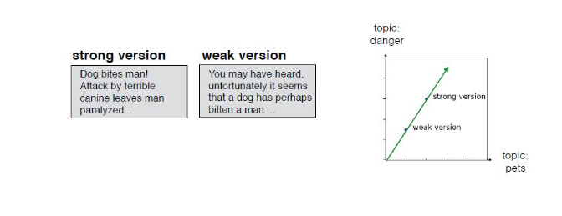

Cosine similarity
● Uses the angle between the lines
● Higher values means more similar
● Maximum value is 1, when angle is 0°
plt.figure(figsize=(4,4))
plt.imshow(plt.imread('cosine.jpg'))
plt.axis('off')
(-0.5, 343.5, 210.5, -0.5)
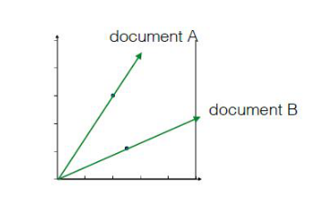

Calculating the cosine similarities
from sklearn.preprocessing import normalize

norm_features = normalize(nmf_data)
print norm_features.shape
print nmf_data.shape
norm_features
(615L, 6L)
(615L, 6L)
array([[ 0., 0., 0., 0., 1., 0.],
[ 0., 0., 1., 0., 0., 0.],
[ 1., 0., 0., 0., 0., 0.],
...,
[ 1., 0., 0., 0., 0., 0.],
[ 1., 0., 0., 0., 0., 0.],
[ 1., 0., 0., 0., 0., 0.]])
df[0]
'RT @MeckeringBoy: Does Pauline secretly wear her\r\n\r\nGrab my pussy\r\n\r\nTee shirt? https://t.co/DquB05XVMk'
current_post = norm_features[0]

similarities = norm_features.dot(current_post)

print(similarities[:10])
print similarities.shape
[ 1. 0. 0. 0.99005859 0.66814589 0.95633953
0. 0.31329499 0. 0.9309553 ]
(615L,)
norm_features_df = pd.DataFrame(norm_features, columns=['cat_'+str(i) for i in range(1,7)])
norm_features_df.head()
 | cat_1 | cat_2 | cat_3 | cat_4 | cat_5 | cat_6
0 | 0.00000 | 0.0 | 0.000000 | 0.000000 | 1.000000 | 0.000000
1 | 0.00000 | 0.0 | 1.000000 | 0.000000 | 0.000000 | 0.000000
2 | 1.00000 | 0.0 | 0.000000 | 0.000000 | 0.000000 | 0.000000
3 | 0.00000 | 0.0 | 0.000000 | 0.140656 | 0.990059 | 0.000000
4 | 0.03113 | 0.0 | 0.249109 | 0.000000 | 0.668146 | 0.700397

find posts resemble the most of 1st post using cosine similarity
current_article = norm_features_df.iloc[250]
current_article
cat_1 0.023034
cat_2 0.000000
cat_3 0.259325
cat_4 0.000000
cat_5 0.965515
cat_6 0.000000
Name: 250, dtype: float64
similar = norm_features_df.dot(current_article)
type(similar)
pandas.core.series.Series
similar.nlargest(10).index
Int64Index([250, 502, 557, 524, 499, 18, 293, 108, 383, 60], dtype='int64')
for i in df.iloc[similar.nlargest(10).index]: print i
@SherryForChange @FoxNews @PaulBabeuAZ @POTUS I give more than I take, I care for my family , I like my Trump pussy hat.
They are a bunch of Fools just used to cause division! This is also the Tactics of George Soros! President Trump n… https://t.co/ba0NfSp0x4
Trump is backing off on China. Next back off on ObamaCare repeal, building a wall, and grabbing pussy. https://t.co/mxTmZMD924
@CTVNews THIS IS WHY . TRUMP IS A REAL MAN WHO TAKES CARE OF HIS OWN FIRST. UNLIKE OUR POLITICALLY CORRECT PUSSY. https://t.co/OCsAYwwctC
Of course, man who turns blind eye from #rapeculture could get job with pussy grabbing president. https://t.co/bLKDK2YC3m
@lordaedonis slaying https://t.co/CBYmVbRXzO
@lordaedonis slaying https://t.co/CBYmVbRXzO
BLACK PEOPLE CANT LIVE HERE! FYP CALLING ME DUMB! https://t.co/4jom9xATcj
BLACK PEOPLE CANT LIVE HERE! FYP CALLING ME DUMB! https://t.co/4jom9xATcj
The rock is the biggest pussy of them all https://t.co/zfy2FoA22X

>>>>>>>>>>>>>>>>>>>>>>>>>>>>>>>>>>>>>>>>>>>>>>>>>>>>>>>>>>>>>>>

NMF applied to Wikipedia articles
In the video, you saw NMF applied to transform a toy word-frequency array. Now it's your turn to apply NMF, this time using the tf-idf word-frequency array of Wikipedia articles, given as a csr matrix articles. Here, fit the model and transform the articles. In the next exercise, you'll explore the result.

Instructions
100xp
- Import NMF from sklearn.decomposition.
- Create an NMF instance called model with 6 components.
- Fit the model to the word count data articles.
- Use the .transform() method of model to transform articles, and assign the result to nmf_features.
- Print nmf_features to get a first idea what it looks like.
SOLUTIONS>
# Import NMF
from sklearn.decomposition import NMF

# Create an NMF instance: model
model = NMF(n_components=6)

# Fit the model to articles
model.fit(articles)

# Transform the articles: nmf_features
nmf_features = model.transform(articles)

# Print the NMF features
print(nmf_features)

>>>>>>>>>>>>>>>>>>>>>>>>>>>>>>>>>>>>>>>>>>>>>>>>>>>>>>>>>>>>>>>>>>>>>

NMF features of the Wikipedia articles
Now you will explore the NMF features you created in the previous exercise. A solution to the previous exercise has been pre-loaded, so the array nmf_features is available. Also available is a list titles giving the title of each Wikipedia article.
When investigating the features, notice that for both actors, the NMF feature 3 has by far the highest value. This means that both articles are reconstructed using mainly the 3rd NMF component. In the next video, you'll see why: NMF components represent topics (for instance, acting!).

Instructions
100xp
- Import pandas as pd.
- Create a DataFrame df from nmf_features using pd.DataFrame(). Set the index to titles using index=titles.
- Use the .loc[] accessor of df to select the row with title 'Anne Hathaway', and print the result. These are the NMF features for the article about the actress Anne Hathaway.
- Repeat the last step for 'Denzel Washington' (another actor).

SOLUTIONS
# Import pandas
import pandas as pd

# Create a pandas DataFrame: df
df = pd.DataFrame(nmf_features, index=titles)

# Print the row for 'Anne Hathaway'
print(df.loc['Anne Hathaway'])

# Print the row for 'Denzel Washington'
print(df.loc['Denzel Washington'])

>>>>>>>>>>>>>>>>>>>>>>>>>>>>>>>>>>>>>>>>>>>>>>>>>>>>>>>>>>>>>>>>>>>>>>>

NMF learns topics of documents
In the video, you learned when NMF is applied to documents, the components correspond to topics of documents, and the NMF features reconstruct the documents from the topics. Verify this for yourself for the NMF model that you built earlier using the Wikipedia articles. Previously, you saw that the 3rd NMF feature value was high for the articles about actors Anne Hathaway and Denzel Washington. In this exercise, identify the topic of the corresponding NMF component.
The NMF model you built earlier is available as model, while words is a list of the words that label the columns of the word-frequency array.
After you are done, take a moment to recognise the topic that the articles about Anne Hathaway and Denzel Washington have in common!

Instructions
100xp

Instructions
100xp
- Import pandas as pd.
- Create a DataFrame components_df from model.components_, setting columns=words so that columns are labeled by the words.
- Print components_df.shape to check the dimensions of the DataFrame.
- Use the .iloc[] accessor on the DataFrame components_df to select row 3. Assign the result to component.
- Call the .nlargest() method of component, and print the result. This gives the five words with the highest values for that component.
SOLUTIONS
# Import pandas
import pandas as pd

# Create a DataFrame: components_df
components_df = pd.DataFrame( model.components_,columns=words)

# Print the shape of the DataFrame
print(components_df.shape)

# Select row 3: component
component = components_df.iloc[3]

# Print result of nlargest
print(component.nlargest())

>>>>>>>>>>>>>>>>>>>>>>>>>>>>>>>>>>>>>>>>>>>>>>>>>>>>>>>>>>>>>>>>>.

Explore the LED digits dataset
In the following exercises, you'll use NMF to decompose grayscale images into their commonly occurring patterns. Firstly, explore the image dataset and see how it is encoded as an array. You are given 100 images as a 2D array samples, where each row represents a single 13x8 image. The images in your dataset are pictures of a LED digital display.

Instructions
100xp

Instructions
100xp
- Import matplotlib.pyplot as plt.
- Select row 0 of samples and assign the result to digit. For example, to select column 2 of an array a, you could use a[:,2]. Remember that since samples is a NumPy array, you can't use the .loc[] or iloc[] accessors to select specific rows or columns.
- Print digit. This has been done for you. Notice that it is a 1D array of 0s and 1s.
- Use the .reshape() method of digit to get a 2D array with shape (13, 8). Assign the result to bitmap.
- Print bitmap, and notice that the 1s show the digit 7!
- Use the plt.imshow() function to display bitmap as an image.

SOLUTIONS>
# Import pyplot
from matplotlib import pyplot as plt

# Select the 0th row: digit
digit = samples[0,:]

# Print digit
print(digit)

# Reshape digit to a 13x8 array: bitmap
bitmap = digit.reshape(13, 8)

# Print bitmap
print(bitmap)

# Use plt.imshow to display bitmap
plt.imshow(bitmap, cmap='gray', interpolation='nearest')
plt.colorbar()
plt.show()

>>>>>>>>>>>>>>>>>>>>>>>>>>>>>>>>>>>>>>>>>>>>>>>>>>>>>>>>>>>>>>>>>>>>>>>

NMF learns the parts of images
Now use what you've learned about NMF to decompose the digits dataset. You are again given the digit images as a 2D array samples. This time, you are also provided with a function show_as_image() that displays the image encoded by any 1D array:
def show_as_image(sample):
bitmap = sample.reshape((13, 8))
plt.figure()
plt.imshow(bitmap, cmap='gray', interpolation='nearest')
plt.colorbar()
plt.show()
After you are done, take a moment to look through the plots and notice how NMF has expressed the digit as a sum of the components!

Instructions
100xp
- Import NMF from sklearn.decomposition.
- Create an NMF instance called model with 7 components. (7 is the number of cells in an LED display).
- Apply the .fit_transform() method of model to samples. Assign the result to features.
- To each component of the model (accessed via model.components_), apply the show_as_image() function to that component inside the loop.
- Assign the row 0 of features to digit_features.
- Print digit_features.
SOLUTIONS>
# Import NMF
from sklearn.decomposition import NMF

# Create an NMF model: model
model = NMF(n_components=7)

# Apply fit_transform to samples: features
features = model.fit_transform(samples)

# Call show_as_image on each component
for component in model.components_:
show_as_image(component)

# Assign the 0th row of features: digit_features
digit_features = features[0,:]

# Print digit_features
print(digit_features)

>>>>>>>>>>>>>>>>>>>>>>>>>>>>>>>>>>>>>>>>>>>>>>>>>>>>>>>>>>>>>>>>>>

PCA doesn't learn parts
Unlike NMF, PCA doesn't learn the parts of things. Its components do not correspond to topics (in the case of documents) or to parts of images, when trained on images. Verify this for yourself by inspecting the components of a PCA model fit to the dataset of LED digit images from the previous exercise. The images are available as a 2D array samples. Also available is a modified version of the show_as_image() function which colors a pixel red if the value is negative.
After submitting the answer, notice that the components of PCA do not represent meaningful parts of images of LED digits!

Instructions
100xp
- Import PCA from sklearn.decomposition.
- Create a PCA instance called model with 7 components.
- Apply the .fit_transform() method of model to samples. Assign the result to features.
- To each component of the model (accessed via model.components_), apply the show_as_image() function to that component inside the loop.
SOLUTIONS>
# Import PCA
from sklearn.decomposition import PCA

# Create a PCA instance: model
model = PCA(n_components=7)

# Apply fit_transform to samples: features
features = model.fit_transform(samples)

# Call show_as_image on each component
for component in model.components_:
show_as_image(component)>
>>>>>>>>>>>>>>>>>>>>>>>>>>>>>>>>>>>>>>>>>>>>>>>>>>>>>>>>>>>>>>>>>>>>

Which articles are similar to 'Cristiano Ronaldo'?
In the video, you learned how to use NMF features and the cosine similarity to find similar articles. Apply this to your NMF model for popular Wikipedia articles, by finding the articles most similar to the article about the footballer Cristiano Ronaldo. The NMF features you obtained earlier are available as nmf_features, while titles is a list of the article titles.

Instructions
100xp

Instructions
100xp
- Import normalize from sklearn.preprocessing.
- Apply the normalize() function to nmf_features. Store the result as norm_features.
- Create a DataFrame df from norm_features, using titles as an index.
- Use the .loc[] accessor of df to select the row of 'Cristiano Ronaldo'. Assign the result to article.
- Apply the .dot() method of df to article to calculate the cosine similarity of every row with article.
- Print the result of the .nlargest() method of similarities to display the most similiar articles. This has been done for you, so hit 'Submit Answer' to see the result!
SOULUTIONS>
# Perform the necessary imports
import pandas as pd
from sklearn.preprocessing import normalize

# Normalize the NMF features: norm_features
norm_features = normalize(nmf_features)

# Create a DataFrame: df
df = pd.DataFrame(norm_features, index=titles)

# Select the row corresponding to 'Cristiano Ronaldo': article
article = df.loc['Cristiano Ronaldo']

# Compute the dot products: similarities
similarities =df.dot(article)

# Display those with the largest cosine similarity
print(similarities.nlargest())

>>>>>>>>>>>>>>>>>>>>>>>>>>>>>>>>>>>>>>>>>>>>>>>>>>>>>>>>>>>>>>.

Recommend musical artists part I
In this exercise and the next, you'll use what you've learned about NMF to recommend popular music artists! You are given a sparse array artists whose rows correspond to artists and whose column correspond to users. The entries give the number of times each artist was listened to by each user.
In this exercise, build a pipeline and transform the array into normalized NMF features. The first step in the pipeline, MaxAbsScaler, transforms the data so that all users have the same influence on the model, regardless of how many different artists they've listened to. In the next exercise, you'll use the resulting normalized NMF features for recommendation!
This data is part of a larger dataset available here.

Instructions
100xp
- Import:
  - NMF from sklearn.decomposition.
  - Normalizer and MaxAbsScaler from sklearn.preprocessing.
  - make_pipeline from sklearn.pipeline.
- Create an instance of MaxAbsScaler called scaler.
- Create an NMF instance with 20 components called nmf.
- Create an instance of Normalizer called normalizer.
- Create a pipeline called pipeline that chains together scaler, nmf, and normalizer.
- Apply the .fit_transform() method of pipeline to artists. Assign the result to norm_features.

SOLUTIONS

# Perform the necessary imports
from sklearn.decomposition import NMF
from sklearn.preprocessing import Normalizer, MaxAbsScaler
from sklearn.pipeline import make_pipeline

# Create a MaxAbsScaler: scaler
scaler = MaxAbsScaler()

# Create an NMF model: nmf
nmf = NMF(n_components=20)

# Create a Normalizer: normalizer
normalizer = Normalizer()

# Create a pipeline: pipeline
pipeline = make_pipeline(scaler, nmf, normalizer)

# Apply fit_transform to artists: norm_features
norm_features = pipeline.fit_transform(artists)

>>>>>>>>>>>>>>>>>>>>>>>>>>>>>>>>>>>>>>>>>>>>>>>>>>>>>>>>>>>

Recommend musical artists part II
Suppose you were a big fan of Bruce Springsteen - which other musicial artists might you like? Use your NMF features from the previous exercise and the cosine similarity to find similar musical artists. A solution to the previous exercise has been run, so norm_features is an array containing the normalized NMF features as rows. The names of the musical artists are available as the list artist_names.

Instructions
100xp

Instructions
100xp
- Import pandas as pd.
- Create a DataFrame df from norm_features, using artist_names as an index.
- Use the .loc[] accessor of df to select the row of 'Bruce Springsteen'. Assign the result to artist.
- Apply the .dot() method of df to artist to calculate the dot product of every row with artist. Save the result as similarities.
- Print the result of the .nlargest() method of similarities to display the artists most similar to 'Bruce Springsteen'.

SOLUTIONS

# Import pandas
import pandas as pd

# Create a DataFrame: df
df = pd.DataFrame(norm_features, index=artist_names)

# Select row of 'Bruce Springsteen': artist
artist = df.loc['Bruce Springsteen']

# Compute cosine similarities: similarities
similarities = df.dot(artist)

# Display those with highest cosine similarity
print(similarities.nlargest())

